Analysis of Atypical Motor Development
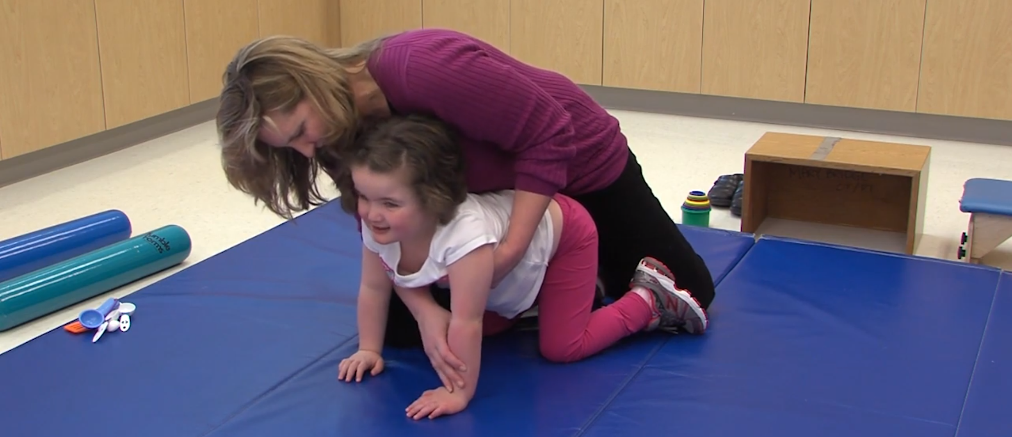
Learning Objectives
This lesson plan is designed to supplement your lab regarding atypical movement patterns and apply knowledge of developmental sequences related to hand use, balance, and movement.
By the end of this activity, the successful student will be able to:
- Analyze movement patterns related to grasp, balance, and transitions between movement patterns.
- Differentiate between typical and atypical patterns of grasp, balance, and transitions and determine sequential development based on developmental patterns.
This activity supports the requirements for:
- The Accreditation Council for Occupational Therapy (ACOTE) standards (2018):
  - OT: B1.1, B.3.2, B.3.6, B.4.25
  - OTA: B1.1, B.3.2, B.3.6, B.4.25
- The Commission on Education for Physical Therapy Education (CAPTE) standards:
  - PT: 7D27,7D28
  - PTA: 7D19, 7D24i, 7D28
Before You Begin
Discussion included lecture on typical development and atypical development. Further Discussion included specific diagnosis or treatment approaches that focus on development.
Readings assigned should include atypical development and possibly motor learning and NDT approaches.

Watch
The following ICE Videos of Molly (Patient ID# 022) are used in this lesson plan. Watch the videos when directed during the Activity, below. The students may need to watch the video once observing Molly and an additional time to observe the therapist.

- Peds, Mat Activity: Intervention Begins (1:55)
- Peds, Mat Activity: Supine to Sit (1:16)
- Peds, Mat Activity: Sit to Quadruped (1:14)
- Peds, Mat activity: Hand Function (2:08)
- Peds, Mat activity: Sit to Stand (3:02)
Materials Needed
- Yoga mats, 1 per student
- Dolls or stuffed animals, 1 per student (child-sized with bendable arms and legs)
- Have students dressed in comfortable clothing to work on the yoga mats
For COVID: additional supplies include mask, gloves, and floor marked with 6 feet placement positions for social distancing.
Activity/Practice Lab
Divide students into small groups of 6 to 8 and position them on their individual mats with their doll. For COVID: social distanced, wearing masks, and gloves if using school-provided dolls. Seat students where they can see the videos.
Watch each video, then direct the students to mirror the therapist and child’s motor patterns, and answer the reflection questions (below).

Video #1:
Peds, Mat Activity: Intervention Begins

Mirroring Therapist
Have students observe and mirror the therapist by placing the doll sitting in the same position as Molly.

Reflection questions:
- What is Molly’s diagnosis and what do they know about similar conditions related to development and function?
- What did they observe about Molly’s entrance, Molly’s sitting/posture, hand use, and vision?
- How did the therapist use therapeutic use of self to create a relationship with Molly and her dad?
- What position did therapist assume? Why do you think she did this?

Video #2:
Peds, Mat Activity: Supine to Sit

Mirroring Molly
Have students observe and mirror Molly’s method of supine to sit moving from supine and falling to prone like Molly did on first trial (at 0:16 seconds), using head and weight bearing on right arm while allowing their leg to come up as seen in trial 2 (from 0:23-0:41 seconds) and lastly one more time like in the last trial.

Reflection questions:
- What muscle groups is Molly using? Why? Is this typical or atypical?
- Why do Molly’s legs come up as she is trying to sit? Which reflexes does Molly use to help her move?

Mirroring Therapist
Have students be the therapist and mirror hand placement seen in the video.

Reflection questions:
- How did the therapist position Molly? Why?
- Did the therapist pull Molly up? Give rationale based on observations.
- How did the therapist motivate Molly during the session?

Video #3:
Peds, Mat Activity: Sit to Quadruped

Mirroring Molly
Have students mirror Molly’s method of moving sit to quadruped and quadruped to sit.

Reflection questions:
- How did Molly’s base of support limit her ability to move from sit to quadruped?
- How is Molly maintaining quadruped?
- How much help does it appear she needs to maintain quadruped?
- Which muscle groups does she use well, and which ones are weak?
- What almost happens to Molly when moving from quadruped to supine? Why?

Mirroring Therapist
Have students place the doll like Molly and position themselves like the therapist. Practice moving the doll from sit to quadruped and quadruped back to sit.

Reflection questions:
- How does the therapist ensure Molly’s safety?
- Sequence the steps needed to move Molly from sit to quadruped.
- What did the therapist do to help Molly complete the sequence and get to quadruped?
- How did the therapist support Molly’s ability to hold quadruped?
- How might you change the sequence to allow Molly greater participation?

Video #4:
Peds, Mat activity: Hand Function

Mirroring Therapist
Have students place the doll and take the doll through the activities in the video:
- Molly in prone on elbows and reaching
- Molly in sitting and reaching for socks and then reaching for spoon crossing midline

Reflection questions:
- Activity analysis of Molly’s sitting posture and base of support. (Point out how therapist stays close in case Molly loses balance)
- Identify grasp patterns Molly demonstrated on each specific tool. Did she show a hand preference?
- How did the therapist facilitate crossing midline? What position was the therapist in relation to Molly when doing this task?

Video #5:
Peds, Mat activity: Sit to Stand

Mirroring Molly
Have students complete sit to stand using their head and shoulders to lead movement.

Reflection questions:
- How does Molly initiate standing? How is that different from their typical method of moving from sit to stand?
- How does she use her arms?
- What type of tone does Molly have?
- What muscles are weak and what substitutions do you observe?

Mirroring Therapist
Have students position the doll like Molly and mirror the therapist to support the movement of sit to stand.

Reflection questions:
- What handling techniques are observed?
- What are the points of stability offered by the therapist?
- Why do you think Molly’s dad joined the session? What additional information did her dad provide to the therapist?
- From your observations, how would you describe Molly and her dad’s relationship?

Reflect and Discuss
Use specific observations from the videos to answer the following questions.
Focus the discussion on muscle groups, strength, coordination, and development.
- What are the next motor skills Molly needs? Be specific regarding balance, mobility, hand use, etc.
- How did the therapist facilitate the next skills? Be specific about the therapist’s position and use of environment. How did the therapist determine when Molly was done, and when it was time to do something different?
- From your observations, what motivated Molly?
- Are there precautions related to Molly’s function or medical diagnosis? What questions might the therapist clarify with Molly’s dad regarding precautions?
- What part does Molly’s dad appear to play in her care and therapy?
- How could occupational therapy and physical therapy practitioners work together in an intervention with Molly?
Futher Activities & Videos
- Using textbook and resources from the class have students create intervention plans for Molly’s next treatment session.
- Using textbook and resources from the class have students discuss standardized and non-standardized tools they might use to assess Molly and rationalize their choice(s).
- Have students pick one session (or use all sessions) to create a documentation note.
- Have students create developmental goals for this case, consistent with their discipline.
- Have students create family education material including activities dad and Molly can do at home that include natural play.

Additional ICE Videos
- Peds, Behavior Management: Developing a Therapy Plan
- Peds, Fine Motor: Letter Formation and Playdough
- Peds, Sensory Integration/Sensory Processing: Scooterboard and Letter activity
- Peds, Fine Motor: Ocular and Visual Perception

Resources for Faculty/Student Reading
Bly, L. (1983) Components of Typical and Atypical Motor Development. The Neuro-Developmental Treatment Association, Inc.

Developed by:
Sherry Stancliff, OTD, OTR/L, SCSS
Faculty
Rowan Cabarrus Community College
Occupational Therapy Assistant Program
Salisbury, NC
and
Adjunct Faculty
Department of Occupational Therapy
Winston Salem State University
Winston Salem, NC

