Administration, Scoring & Interpretation:
Barthel, Katz & Section GG
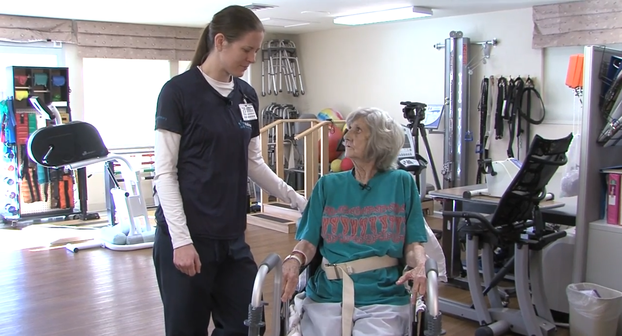
Learning Objectives
By the end of this activity, the successful student will:
- Select, administer, and interpret appropriate assessments to evaluate a variety of diagnoses in pediatric and adult populations.
- Assess the need for continuation or discharge from occupational therapy services in pediatric and adult populations.
- Create an appropriate treatment or discharge plan, including writing goals and making referrals.
This activity supports the requirements for ACOTE standards (2018):
- B.4.5, B.4.6, B.4.7, B.4.8, B.4.20, B.4.26, B.4.28, B.6.1

Pre-Class Activity
- Students will familiarize themselves with the Barthel Index & Katz Index of Independence in ADLs administration instructions and scoring criteria.
- Students will read the following research articles:
  - Comparison of the psychometric characteristics of the FIM, 5-item BI & 10-item BI in patients with stroke (https://pubmed.ncbi.nlm.nih.gov/12122181/)
  - Predictors of IADL performance in patients with stroke (https://pubmed.ncbi.nlm.nih.gov/33727902)
  - Dependency in ADLs during the first year after stroke (https://www.ncbi.nlm.nih.gov/pmc/articles/PMC8606514)

- Students will participate in a discussion forum to answer the following question:
- Discuss the benefits and limitations of using the Barthel and Katz in clinical practice.
- Think about the assessments' abilities to predict independence, safety, discharge planning, and functional outcomes for patients.
- Are these assessments sensitive enough to detect small changes in functional independence (e.g., moderate assistance increased to minimal assistance)?
Whole Group Activity: Discussion
- Whole group discussion regarding the benefits / limitations of these assessments (e.g., sensitivity, validity, reliability) to introduce the topic, bridge the discussion forum to the classroom, and prep students for the small group activity.
Small Group Activity: ICE Video Case Studies
- Student groups will be assigned one patient diagnosis from the list below in the ICE video library and watch all of the selected patient’s videos.

  - Hip Fracture
  - Femur Fracture
  - Total Hip Replacement
  - Multiple Sclerosis
  - Stroke (several patients)
  - Dementia

- Students will produce a brief occupational profile, problem list, and functional assessment.
- Students will administer, score, and interpret the findings of the following assessments based on their observations while watching the client videos and clinical reasoning skills.
  - Barthel Index
  - Katz Index of Independence in ADLs
  - Section GG Assessment
- Student groups will determine the need for skilled occupational therapy services, goals to be addressed in the plan of care, safe discharge planning, and potential referral to other specialists / disciplines.
- Students will report their findings and scoring justifications to the whole group based on their assessment of the functional performance of the client and their clinical reasoning skills.

Acknowledgment
Melissa Turpin, OTD, OTR/L, CTP
Assistant Professor
Presbyterian College

