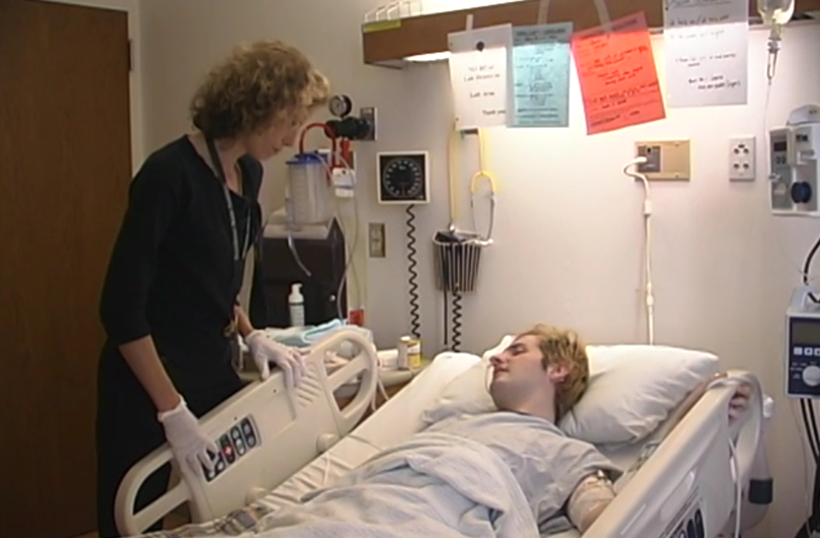

Understanding and Utilizing the ICF Model
for Effective Patient Care

Prerequisites
Students should be familiar with the ICF model prior to this learning experience. This learning experience is designed to reinforce knowledge using a case study. Students should ideally have completed a separate activity in which they watch videos of Ben and formulate an examination complete with findings (see “Ben - Physical Therapy Initial Evaluation”).
Links to helpful resources
ICF model overview WHO website
ICF model in detail
Learning Objectives
By the end of this activity, the successful student will:
- Gain a better understanding of the biopsychosocial model construct of the ICF model
- Review and define the terms health condition, impairment, activity, and participation
- Differentiate between internal and external contextual factors
- Properly assign a finding from Ben’s examination as an impairment, activity limitation or participation restriction according to the ICF model
- Problem solve findings from Ben’s examination as either an internal or an external contextual factor according to the ICF and discuss potential overlap areas in the ICF model
- Discuss ways in which the ICF model can be used for treatment planning

Watch
Watch the following videos of Ben (001):
- Acute Care Part 1: Bed Mobility Scooting Up in Bed
- Acute Care Part 2: Monitoring Blood Pressure in Supine
- Acute Care Part 3: Monitoring Blood Pressure While Sitting
- Acute Care Part 4: Dizziness while Standing
- Acute Care Part 5: Bed to Chair Transfer

Learning Activities
- Discuss how the biopsychosocial model differs from the disability model. List the differences and the similarities.
  - Differences:
  - Similarities:

- Why do you think this model has been adopted by the World Health Organization and is used worldwide? Be specific. How does this assist something like evidence-based practice?

- Define and give some examples of the following terms:
  - impairment (body function/structure)
  - activity (functional task)
  - participation (life roles)

- List what are considered internal (personal) factors and external (environmental). Remember that when considering a patient example these factors can be positive or negative.
  - Internal factors:
  - External factors:

- Working in small groups or as individuals, review the chart and medical background information of Ben, a young stroke survivor you saw in several video clips. If necessary review the videos to refamiliarize yourself. You may want to write down some observations for clarity.

- Identify what you think is Ben’s primary health condition (there may be more than one):
  - Rationalize your choice:
  - How do you determine the difference between primary health condition and co-morbidities?

- List ways in which Ben’s health conditions impacted the examination process. Provide detailed examples from the video:

- Complete the ICF template: determine Ben’s impairments, functional activity limitations, and participation restrictions as well as his contextual factors. Remember that all patients have positive and negative factors in their activity and participation domains.

- Discuss or consider how the ICF model can be helpful for goal writing. Defend your choice.
  - Should goals be focused on impairments, functional activities, participation restrictions? Defend your answer.

- List the ways in which the ICF model can be helpful to patient care in terms of examination and treatment planning.

- Based on Ben’s examination, take some time to try some goal writing- remember to include in every goal: time frame, level of assist (or that the patient will be independent), assistive devices needed (or none), specific to a given task, functional, and measurable.

